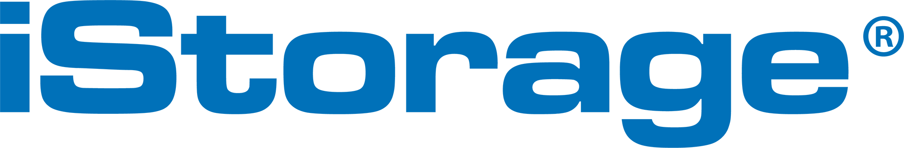

For immediate release
03 June, 2019

iStorage Launches datAshur PRO²: their most secure PIN authenticated, hardware encrypted USB flash drive

Just weeks after unveiling the future of cloud security in the form of cloudAshur, iStorage, the award-winning developer and manufacturer of hardware encrypted data storage devices, has announced the launch of the datAshur PRO² - a PIN authenticated, hardware encrypted USB flash drive with next generation security capabilities.

The ultimate in secure USB flash drive technology, the datAshur PRO² boasts an on-device crypto chip which offers 100% real-time military grade hardware encryption, iStorage’s largest ever 512GB capacity, is OS and platform independent with no software required and is cross-platform compatible with systems such as MS Windows, macOS, Linux, Android, Chrome as well as applications such as medical equipment, printers and scanners; anything in fact that is equipped with a USB drive.

Ultra Secure and easy to use, datAshur PRO² offers stringent portable data security thanks to a built-in AES-XTS 256-bit full disk hardware encrypted engine.

Uniquely, the device incorporates the same Common Criteria EAL4+ ready secure microprocessor technology as iStorage’s award-winning diskAshur² range. This provides unimpeachable security against hackers and both detects and responds to tampering thanks to features such as dedicated hardware to protect against SPA/ DPA/SEMA, DEMA attacks, advanced protection against physical attacks and environmental protection.

The Superspeed USB 3.2 (Generation 1x1) is also backwards compatible with older USB ports for complete convenience and is easy to use; the authorised user unlocks the device with their unique 7-15-digit PIN – simple as that.

Other clever design features include an inactivity autolock, which will see the datAshur PRO² lock down after a pre-determined period of inactivity. The datAshur PRO² can be used as a fixed disk or removeable media, offers read only (write protect) configuration and is IP58 certified. Dust and water resistant, a hard anodised and ruggedized extruded aluminium protective sleeve means the datAshur PRO² is robust and hardwearing, suitable for use in even the most hostile of environments.

Further user security is assured with a self-destruct feature, whitelisting on networks and a brute force hack defence mechanism.,

CEO of iStorage John Michael, said, “datAshur PRO² sets a new standard in USB flash drive technology. It has unprecedented security features and safety protocols. It is a substantial leap forward from its market leading predecessor, the datAshur PRO USB flash drive and has been designed to be impervious to sophisticated threats from a range of sources. It is our most secure and highest capacity hardware encrypted USB flash drive yet.”
(continued on next page..)
To find out more, visit: www.istorage-uk.com, view the data sheet: https://istorage-uk.com/istorage-datashur-pro2/, or contact +44 (0) 20 8991 6260.

End.

About
iStorage is the trusted global leader of award-winning PIN authenticated, hardware encrypted data storage devices. Delivering the most innovative products to securely store and protect data to military specified encryption levels; safeguarding valuable business information whilst ensuring compliance to regulations and directives.

Industry Awards won: 2013 UK IT Industry Awards Winner, Computing Security Excellence 2016 Awards SME Solution Award Winner, 2017 UK IT Industry Awards - Highly Commended for the UK Innovation and Entrepreneurship Award, PC PRO Security Product of the Year 2017 for diskAshur PRO² and 2018 Security Today Magazine New Product of the Year – Winner in the Tools and Hardware Category. iStorage is also featured on The Sunday Times Hiscox Tech Track 100 2016 List of Britain’s fastest growing tech companies, FT 1000 Europe’s Fastest Growing Companies 2017, London Stock Exchange Group’s 1000 companies to Inspire Britain 2018 and 2018 FT Future 100 UK list of the fast-growing businesses that are shaping the future of their sector and making positive impact on business and society. 2018 John Michael, recognised as Top 100 BAME Leader in Tech. 2019 diskAshur PRO² wins Best Encryption product at Infosec Awards Winner Cyber Defense Magazine.

Contact
iStorage Limited
MEDIA CONTACT: Holli Cheung
EMAIL: holli.cheung@istorage-uk.com
TEL: +44 (0) 20 8991 6286

